**Project Design Phase**

**Solution Architecture**

|  |  |
| --- | --- |
| Date | 15 February 2026 |
| Team ID | LTVIP2026TMIDS54443 |
| Project Name | Exploratory-Analysis-Of-RainFall-Data-In-India-For-Agriculture |
| Maximum Marks | 4 Marks |

**Solution Architecture:**

Solution architecture is a complex process – with many sub-processes – that bridges the gap between business problems and technology solutions. Its goals are to:

* Find the best tech solution to solve existing business problems.
* Describe the structure, characteristics, behavior, and other aspects of the software to project stakeholders.
* Define features, development phases, and solution requirements.
* Provide specifications according to which the solution is defined, managed, and delivered.

**Example - Solution Architecture Diagram:**

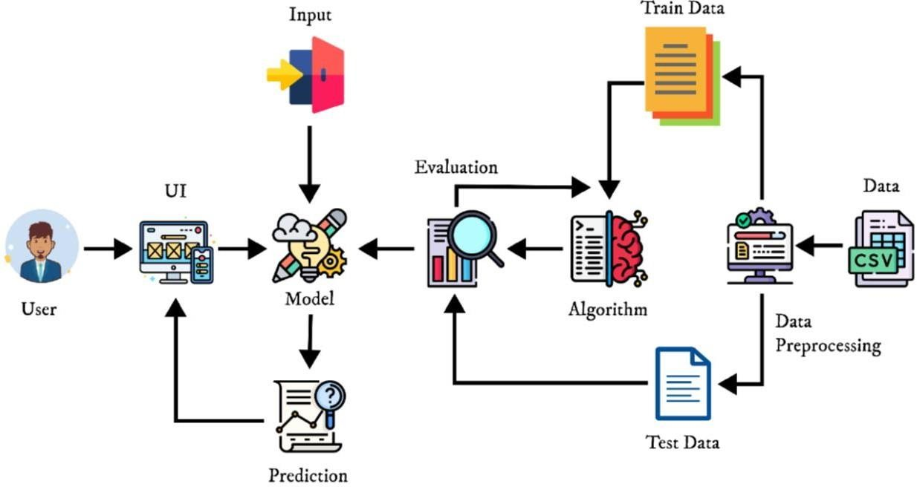

**SOLUTION ARCHITECTURE**

**(Minimum Viable Architecture/ Product)**

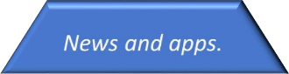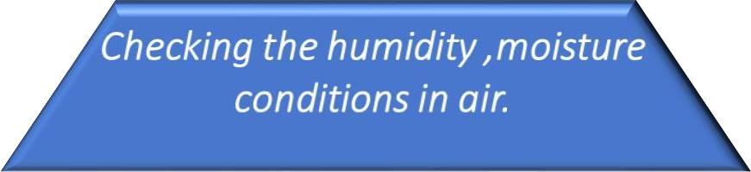

Checking

the

moisture conditions

in

air

seems to be

reliable

and

well worked

.



Reliablity

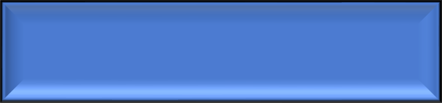

In

current

situation

people

uses

weather

report

channels

to predict

rainfall.



Usability

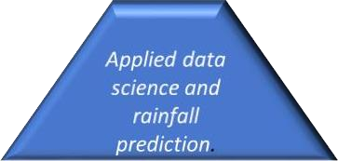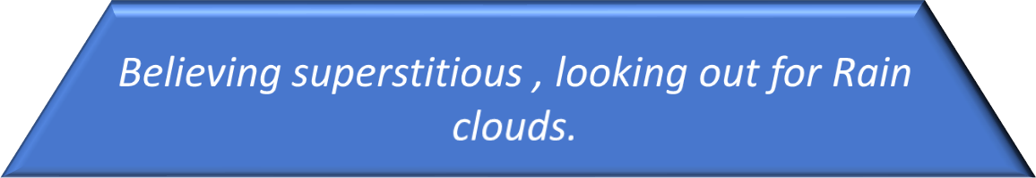

Design



THIS

IS THE

FUTURE

!



Functionality



In

olden

days

people

used

to

look

at the

skies

and

predict

the

rainfall

.